Analysis 2

Extract and draw the class diagram for the module.

Module register as a member
- Customer access the app: Need a class MainMenuView:
+ Register button: subRegisterForm
- The system show a register form : Need a class RegisterView
+ Input for name: inName
+ Input for address: inAddress
+ Input for phone number: inPhoneNumber
+ Input for email: inEmail
+ Input for password: inPassword
+ Input for confirm password: inConfirmPassword
+ Register button: subRegister
+ Back button: subBack
- The customer register an account: Need a method register():
+ Input: name, address, phone number, email, password
+ Output: boolean
+ Assign to class Customer
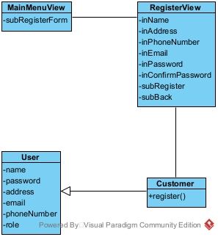

Module view customer statistics by revenue
- Management staff open the open and login : need a class LoginView
+ Input for username: inUsername
+ Input for password: inPassword
+ Login button: subLogin
- System displays an interface that has at least 1 button view statistic: Need a class StaffMenuView:
+ View statistics button: subStatistic
- System shows an interface that has at least 1 button view customer statistic: Need a class StatisticsView
+ View customer statistics button: subViewCustomerStatistics
- The system displays an interface to enter start and end date: Need a class CustomerStatisticsView
+ Input for start date: inStartDate
+ Input for end date: inEndDate
+ Display list of customer: outsubCustomerStatistics
+ Search button: subSearch
- Enter start and end date for customer statistics: Need a method getCustomerStatistics:
+ Input: start date, end date
+ Output: list of customer
+ Assign to class CustomerStatistics
- The system display an interface with list of a customer’s invoice: Need a class CustomerInvoiceView
+ List of invoice: outsubCustomerInvoice
+ Back button: subBack
- Get all invoice from a customer in a period: Need method getInvoiceByCustomer():
+ Input: customer id, start date, end date
+ Output: list of Invoice
+ Assign to class Invoice
- The system display an Invoice: Need a class InvoiceView
+ Invoice detail: outInvoiceDetail
+ Back button: subBack
- Get an invoice by id: Need a method getInvoice()
+ Input: invoice id
+ Output: invoice detail
+ Assign to class Invoice
- Get order detail from invoice: Need a class getOrder()
+ Input: invoice id
+ Output: List of item in the order
+ Assign to class Order

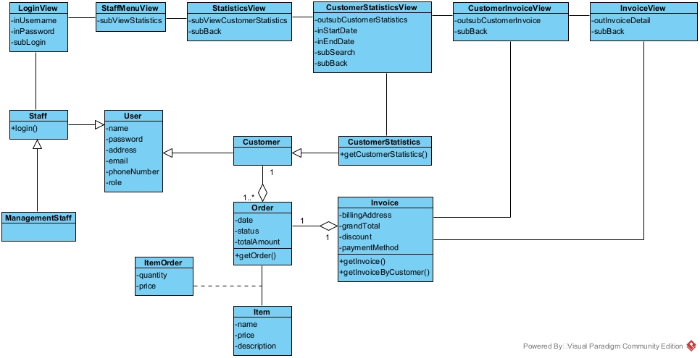

Draw the state diagram for the module.

Module register as a member
- From MainMenuView, clicking the register button, the system will move to RegisterView
- From RegisterView, after enter name, address, phone number, email, password, confirm password and click Register, the system will save the account and finish
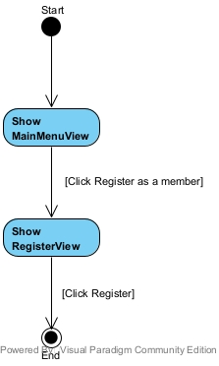

Module view customer statistics by revenue
- From LoginView, the management staff enter username, password and click Login, the system will display the StaffMenuView
- From StaffMenuView, the staff click Statistics, the system move to StatisticsView
- From StatisticsView, after clicking view Customer statistics, the CustomerStatisticsView will display
- From CustomerStatisticsView, after enter start date, end date and click enter, a list of customer will be display. After clicking a customer, the system will move to CustomerInvoiceView.
- From CustomerInvoiceView, after click on an Invoice, the system will display the InvoiceView
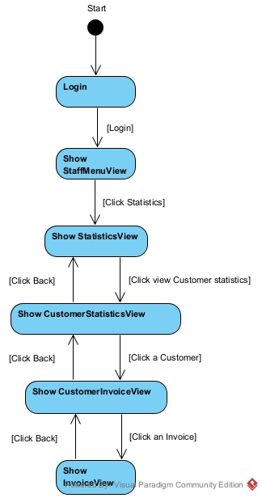

Write detail scenario(ver 2.0)

Module register as a member
- In main menu interface, customer click register
- Class MainMenuForm call the class RegisterForm
- The class RegisterForm display itself to the customer
- The customer input information and click register
- Class RegisterForm call the class Customer
- Class Customer execute register()
- Class Customer return the result to RegisterView
- Class RegisterView display success message

Module view customer statistics by revenue
- In the login interface, management staff enter username, password and click Login
- The class LoginView call the class Staff
- The class Staff execute login()
- The class staff return the result to the class LoginView
- The class LoginView call the class StaffMenuView
- The class StaffMenuView display to the management staff
- In main menu interface, management staff click view statistics
- Class StaffMenuView call the class StatisticsView
- The class StatisticsView display
- The staff click view customer statistics by revenue
- The class StatisticsView call the class CustomerStatisticsView
- The class CustomerStatisticsView display
- The staff enter date and click search
- The class CustomerStatisticsView call the class CustomerStatistics
- The class CustomerStatistics execute getCustomerStatistics
- The class CustomerStatistics return the result
- The class CustomerStatisticsView display the result
- The staff click a Customer
- The class CustomerStatisticsView call the class CustomerInvoiceView
- The class CustomerInvoiceView call the class Invoice
- The class Invoice execute getInvoiceByCustomer()
- The class Invoice return the result
- The class CustomerInvoiceView display the result
- The staff click an invoice
- The class CustomerInvoiceView call the class InvoiceView
- The class InvoiceView call the class Invoice
- The class Invoice execute getInvoice()
- The class Invoice call the class Order
- The class Order execute getOrder()
- The class Order return the result to the class Invoice
- The class Invoice return the result
- The class InvoiceView display the result

Draw the communication diagram for the module.

Module register as a member
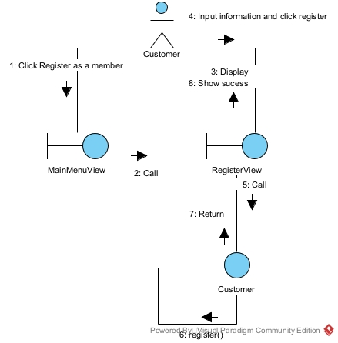

Module view customer statistics by revenue
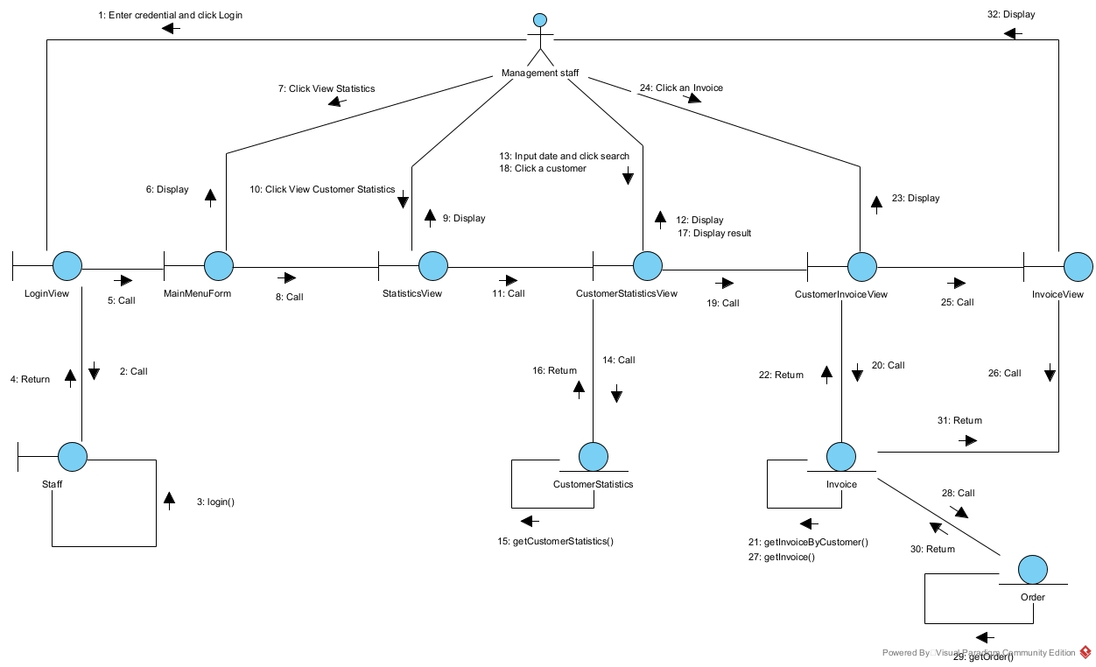

Draw the sequence diagram for the module.

Module register as a member
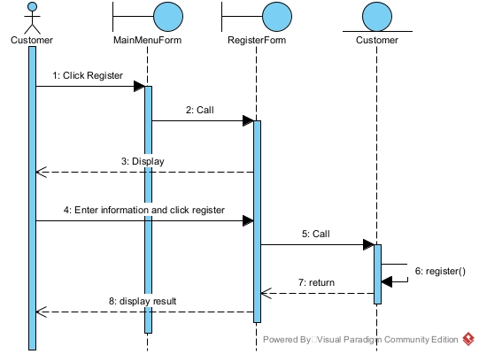

Module view customer statistics by revenue
